Road Accident

1.How many total records are there in the accident database?

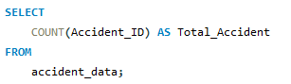

Ans



2. Display the top 5 records (Casualties_Count)

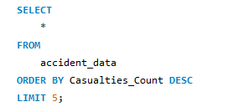

Ans

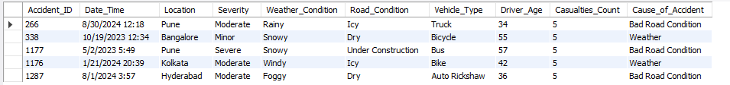

3. How many accidents happened in the morning (6 AM - 12 PM), afternoon (12 PM - 6 PM), and night (6 PM - 6 AM)?

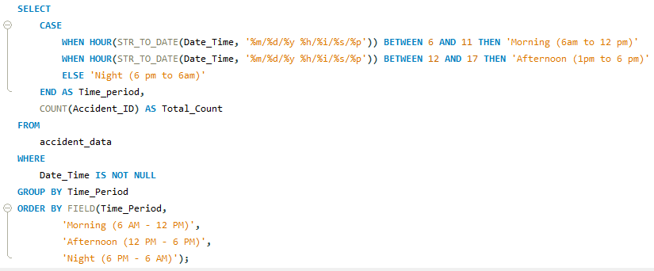

Ans:

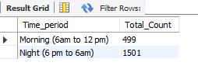

4. How many accidents are categorized by severity (Minor, Moderate, Severe)?

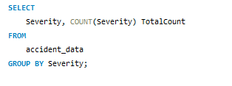

Ans:

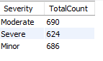

5 In which months did the most severe accidents occur?

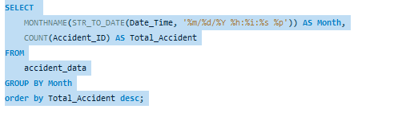

Ans:

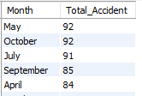

6 . Which city had the highest number of accidents?

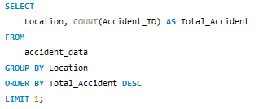

Ans:



7. Which location had the least number of accidents?

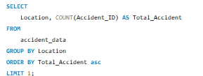

Ans:



8. During which weather condition did the most accidents occur?

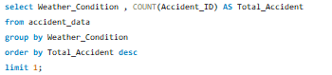

Ans



9. What is the accident ratio on wet roads vs. dry roads?

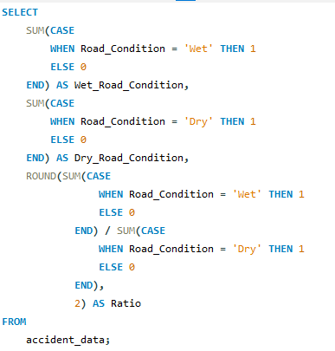

Ans



* + 10. Which vehicle type was involved in the most accidents?

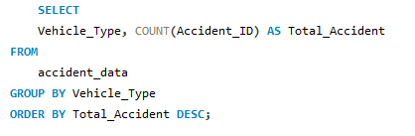

Ans

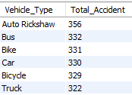

11. What is the accident pattern based on driver age groups? (e.g., 18-25, 26-40, 41-60)

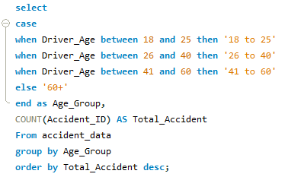

Ans:

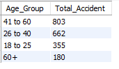

* + 12. How many accidents resulted in 3 or more casualties?

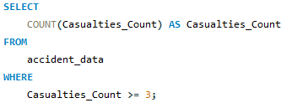

Ans



* + 13 Which accident cause led to the highest number of casualties?

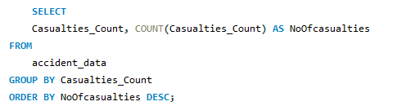

Ans:

